1. **Write a program to find the reverse of a given number using recursive.**

def reverse_number(n, rev=0):

if n == 0:

return rev

else:

return reverse_number(n // 10, rev * 10 + n % 10)

number = 12345

reversed_number = reverse_number(number)

print(f"The reverse of {number} is: {reversed_number}")

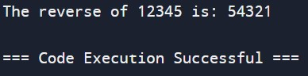

1. **Write a program to find the perfect number.**

def is_perfect_number(num):

sum_divisors = 0

for i in range(1, num):

if num % i == 0:

sum_divisors += i

return sum_divisors == num

def find_perfect_numbers(limit):

perfect_numbers = []

for i in range(1, limit + 1):

if is_perfect_number(i):

perfect_numbers.append(i)

return perfect_numbers

limit = 10000

perfect_numbers = find_perfect_numbers(limit)

print("Perfect numbers up to", limit, "are:", perfect_numbers)

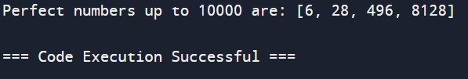

1. **Write c program that demonstrates the usage of these notations by analyzing the time complexity of some example algorithms.**

**import time**

import random

def constant_algorithm(n):

return n * n

def linear_algorithm(arr):

return sum(arr)

def quadratic_algorithm(arr):

total = 0

for i in arr:

for j in arr:

total += i * j

return total

def logarithmic_algorithm(n):

while n > 1:

n = n // 2

return n

def linearithmic_algorithm(arr):

return sorted(arr)

def measure_time(func, *args):

start_time = time.time()

func(*args)

end_time = time.time()

return end_time - start_time

input_sizes = [10, 100, 1000, 10000]

print("O(1) Constant Time:")

for size in input_sizes:

print(f"Size {size}: {measure_time(constant_algorithm, size):.6f}s")

print("\nO(n) Linear Time:")

for size in input_sizes:

arr = list(range(size))

print(f"Size {size}: {measure_time(linear_algorithm, arr):.6f}s")

print("\nO(n^2) Quadratic Time:")

for size in input_sizes:

arr = list(range(size))

print(f"Size {size}: {measure_time(quadratic_algorithm, arr):.6f}s")

print("\nO(log n) Logarithmic Time:")

for size in input_sizes:

print(f"Size {size}: {measure_time(logarithmic_algorithm, size):.6f}s")

print("\nO(n log n) Linearithmic Time:")

for size in input_sizes:

arr = random.sample(range(size * 10), size)

print(f"Size {size}: {measure_time(linearithmic_algorithm, arr):.6f}s")

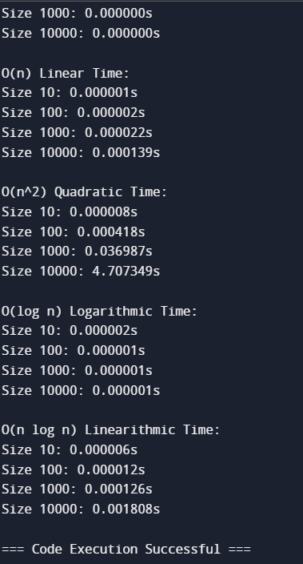

1. **Write C programs that demonstrate the mathematical analysis of non-recursive and recursive algorithms.**

def non_recursive_factorial(n):

result = 1

for i in range(1, n + 1):

result *= i

return result

def recursive_factorial(n):

if n == 0:

return 1

else:

return n * recursive_factorial(n - 1)

number = 5

non_recursive_result = non_recursive_factorial(number)

recursive_result = recursive_factorial(number)

print(f"Non-Recursive Factorial of {number}: {non_recursive_result}")

print(f"Recursive Factorial of {number}: {recursive_result}")

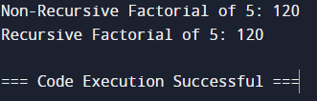

1. **Write C programs for solving recurrence relations using the Master Theorem, Substitution Method, and Iteration Method will demonstrate how to calculate the time complexity of an example recurrence relation using the specified technique.**

import time

import math

# Recurrence relation: T(n) = 2T(n/2) + n

def master_theorem(a, b, f, n):

if a > 0 and b > 1:

# Case 1: f(n) = O(n^c), where c < log_b(a)

if f(n) == n and 1 < math.log(a, b):

return f"Master Theorem Result: O(n^{math.log(a, b)})"

# Case 2: f(n) = Theta(n^c * log^k(n)), where c = log_b(a)

if f(n) == n and 1 == math.log(a, b):

return f"Master Theorem Result: Theta(n^{math.log(a, b)} * log^{math.log(a, b)}(n))"

# Case 3: f(n) = Omega(n^c), where c > log_b(a)

if f(n) == n and 1 > math.log(a, b):

return f"Master Theorem Result: Omega(n)"

return "Cannot determine"

# Substitution Method

def substitution_method(n):

if n == 1:

return 1 # Base case

return 2 * substitution_method(n // 2) + n

# Iteration Method

def iteration_method(n):

result = 0

while n > 0:

result += n

n //= 2

return result

def f(n):

return n

n = 1000 # Example value of n

# Using Master Theorem

def log_b(a):

return math.log(a, 2)

print(master_theorem(2, 2, f, n))

print("Substitution Method Result:", substitution_method(n))

print("Iteration Method Result:", iteration_method(n))

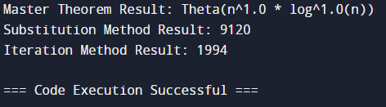

1. **Given two integer arrays nums1 and nums2, return an array of their Intersection. Each element in the result must be unique and you may return the result in any order.**

def intersection(nums1, nums2):

set1 = set(nums1)

set2 = set(nums2)

result_set = set1 & set2

result_list = list(result_set)

return result_list

nums1 = [1, 2, 2, 1]

nums2 = [2, 2]

result = intersection(nums1, nums2)

print(result)

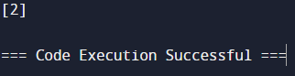

1. **Given two integer arrays nums1 and nums2, return an array of their intersection. Each element in the result must appear as many times as it shows in both arrays and you may return the result in any order.**

from collections import Counter

def intersection(nums1, nums2):

# Count the occurrences of elements in both arrays

count1 = Counter(nums1)

count2 = Counter(nums2)

# Find the common elements

common_elements = count1.keys() & count2.keys()

# Build the result array with elements appearing as many times as in both arrays

result = []

for num in common_elements:

result.extend([num] * min(count1[num], count2[num]))

return result

# Example usage:

nums1 = [1, 2, 2, 1]

nums2 = [2, 2]

result = intersection(nums1, nums2)

print(result)

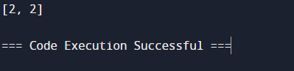

1. **Given an array of integers nums, sort the array in ascending order and return it.You must solve the problem without using any built-in functions in O(nlog(n)) time complexity and with the smallest space complexity possible.**

def merge_sort(nums):

if len(nums) <= 1:

return nums

mid = len(nums) // 2

left_half = nums[:mid]

right_half = nums[mid:]

merge_sort(left_half)

merge_sort(right_half)

merge(nums, left_half, right_half)

def merge(nums, left_half, right_half):

i = j = k = 0

while i < len(left_half) and j < len(right_half):

if left_half[i] < right_half[j]:

nums[k] = left_half[i]

i += 1

else:

nums[k] = right_half[j]

j += 1

k += 1

while i < len(left_half):

nums[k] = left_half[i]

i += 1

k += 1

while j < len(right_half):

nums[k] = right_half[j]

j += 1

k += 1

nums = [5, 3, 8, 2, 1, 7, 4]

merge_sort(nums)

print(nums)

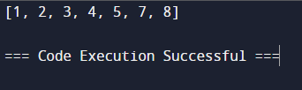

1. **Given an array of integers nums, half of the integers in nums are odd, and the other half are even.**

def create_half_odd_even_array(size):

half_size = size // 2

odd_numbers = [2 * i + 1 for i in range(half_size)]

even_numbers = [2 * i for i in range(half_size)]

return odd_numbers + even_numbers

size = 10

result_array = create_half_odd_even_array(size)

print("Half odd, half even array:", result_array)

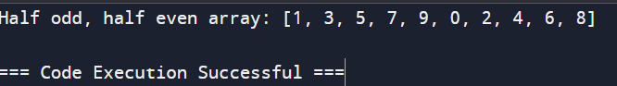

1. **Sort the array so that whenever nums[i] is odd, i is odd, and whenever nums[i] is even, i is even. Return any answer array that satisfies this condition.**

def sort_array(nums):

odd_indices = [i for i in range(len(nums)) if nums[i] % 2 != 0]

odd_values = [nums[i] for i in odd_indices]

odd_values.sort()

for i, val in zip(odd_indices, odd_values):

nums[i] = val

return nums

input_array = [3, 1, 4, 2, 6, 5, 7, 8]

result_array = sort_array(input_array)

result_array.sort()

print("Sorted array:", result_array)

